**CSE1901 - Technical Answers to Real World Problems (TARP)**

**Project Report**

**Intruder Detection and Mailing System**

*By*

19BCE1313 Bhavesh Kumar VD

19BCE1305 Kshitij Upadhyay

B. Tech Computer Science and Engineering

*Submitted to*

**Neelanarayanan V**

**School of Computer Science and Engineering**



*April 2022*

**DECLARATION**

I hereby declare that the report titled “**Intruder Detection and Mailing System”** submitted by me to VIT Chennai is a record of bonafide work undertaken by me under the supervision of **Neelanarayanan V**, School of Computer Science and Engineering, Vellore Institute of Technology, Chennai.

**Bhavesh Kumar VD Kshitij Upadhyay**

**19BCE1313 19BCE1305**

i

**CERTIFICATE**

Certified that this project report entitled “**Intruder Detection and Mailing System”** is a bonafide work of **Bhavesh Kumar VD (19BCE1313), Kshitij Upadhyay(19BCE1305) ,** and they carried out the project work under my supervision and guidance for CSE1901 - Technical Answers to Real-World Problems (TARP).

**Neelanarayanan V**

SCOPE, VIT Chennai

ii

**ACKNOWLEDGEMENT**

The team wishes to express our thanks and gratitude to our amazing project guide, Dr. Neelanarayanan V, for the unfading patience and treasured guidance that has been offered, through the entire course of the project.

We are also grateful to Dr. Ganesan R., Dean of SCOPE, VIT Chennai, for the opportunity he has given us in the form of the various facilities we might have availed towards the development of our project and for his ever-present support.

Sincere thanks to the remaining faculty of our prestigious institution who may have contributed either directly or indirectly to our project.

Lastly, and most importantly, we thank our parents, family and friends who bore with us through the entire process of creation and improvisation of the project.

**Bhavesh Kumar VD - Reg. No. 19BCE1313**

**Kshitij Upadhyay- Reg. No. 19BCE1305**

iii

**ABSTRACT**

The city's most valuable asset is itself Residents and their belongings. The theft warning system Absolutely essential modern metropolitan ideas So that the inhabitants of the frame can lead a quality life. this Intruder alert system are used to detect intruders, Generates an alert to authorized people. Build on it Incident responders can investigate and resolve issues Measures required at this time. We are using Python and some of it’s important modules like face recognition to capture the image and classify it into intruder or not based on the accuracy and then if image is found to be unknown immediately sending it to the specified mail.​

​

​

The flow of data in this project is as follows:

iv

**CONTENTS**

Declaration i

Certificate ii

Acknowledgement iii

Abstract iv

1 Introduction 7

1.1 Objective and goal of the project . . . . . . . . . . . . . . . . . …….

1.2 Problem Statement. …. . . . . . . . . . . . . . . . . . . . . . . . . . . . . .

1.3 Motivation . . . . . . . . . . . . . . . . . . . . . . . . . . . . . …………...

1.4 Challenges . . . . . . . . . . . . . . . . . . . . . . . . . . . . . …………....

2 Literature Survey . . . . . . . . . . . . . . . . . . . . . . . . . . . . . . .. . . . . . . . . . . . . 8

3 Requirements Specification 15

3.1 Hardware Requirements . . . . . . . . . . . . . . . . . . . . . . . . . …

3.2 Software Requirements . . . . . . . . . . . . . . . . . . . . . . . . . . . .

4 System Design . . . . . . . . . . . . . . . . . . . . . . . . . . . . . . . . . . . . . . . . . 16

5 Implementation of System . . . . . . . . . . . . . . . . . . . . . . . . . . . . . . . . .17

6 Results & Discussion . . . . . . . . . .. . . . . . . . . . . . . . . . . . . . . . . . . . .18

7 Conclusion and Future Work . . . . . . . . . . . . . . . . . . . . . . . . . . . . . . .19

8 References . . . . . . . . . . . . . . . . . . . . . . . . . . . . . . . . . . . . . . . . . . . .20

v

**1. Introduction**

**1.1 Objective and goal of the project**

The sole objective of this project is to intruder detection system which can be used anywhere

**1.2 Problem Statement**

In Today's world security is one of the major concern for every individual and unlike before generation nowadays people live in small families and there are a lot of occasions when no one stays at home. We have security/cctv cameras nowadays which works 24x7 and records every activity in it’s range but no one has time to watch the whole recording and that is where our project comes handy.​

It detects intruder and immediately saves it’s image in local disk as well as sends it to the specified email of the owner which can be viewed immediately. It also acts as a permanent proof which can’t be destroyed by any means.​

**1.3 Motivation**

In India, as we know security and privacy gets a little complicated , many fear leaving their house without security in many parts of india so in those situations this will be really useful and where you want privacy also like your private room also this can be used

**1.4 Challenges**

The challenges faced during implementation of our intruder detection and mailing system are :

* Studying all papers to find existing work and finding the best available method.
* Implementing using python modules like face recognition and dlib
* Figuring out the mailing part and implementing it.
* Collecting real world data and then testing our system as many people have privacy issues.

**2. Literature Survey**

| Name | Author | Model | Performance | Methodology |
| --- | --- | --- | --- | --- |
| An IoT based House Intruder Detection and Alert System using Histogram of Oriented Gradients |  | The following human-detuction relationship model was decided on the basis of users’ answers   1. Explorative stage      1. Affective stage      1. Stable stage | From the data obtained, we have 100 photos for human intruder case and 30 photos of non-intruder case (animal object). To calculate accuracy, a confusion matrix is used, as shown by Table 2. The number of correctly detected photos is 117 photos. From the results of accuracy testing, the accuracy of the home security system using the HOG and SVM methods is 90% with the true positive rate (TPR) of 97.8% and the False Positive Rate (FPR) of 28.2%. The results outperform the works of Patidar et al. (2014) | Based on the problems faced, an IoT system with an additional capability of detecting and recognizing intruders using HOG and SVM methods is proposed (Dalal and Triggs, 2005; Satpathy et al., 2014). The system is implemented on Raspberry Pi 3 (Kumar and Reddy, 2016) and Arduino (Abdullah et al., 2016; Badamasi, 2014). The Raspberry Pi 3 is used because this board can process image processing with low power from computer and laptop. Arduino is used to integrate all the electronic devices in one environment. To detect the motion, the PIR sensor is utilized (Sahoo and Pati, 2017). In this section, the system design approach for the proposed home security system is discussed. |
| A Smart Intruder Alert System Based on Microprocessor and Motion Detection | Saleh Ahmad Khan    Md. Sazzad Ahmed  Ishtiaq Ahmad | Researchers are only studying existing models | Size small  Required steps 2  Power 5V DC  Time 3s | the confirmation message to the respective authority in real time. For that reason, motion detection method is adopted which is done by the PIR sensor. OverviewofSystem  Motion estimation |
| Intrusion Detection System | Mr Mohit Tiwari, 2 Raj Kumar, 3Akash Bharti, 4Jai Kishan | Local (when you have just one system to monitor)  Client-server for centralised analysis | Good performance | A. Anomaly Based Detection Technique: An anomaly- based intrusion detection system, is a technique for detecting both network and computer intrusions and misuse by monitoring system activity and classifying it as either normal or anomalous. The classification is based on some rules, rather than patterns or signatures, and attempts to detect any type of malicious activity that falls out of normal system operation. While the signature- based systems can only detect attacks for which a signature has previously been created.  A. Advantages of this anomaly detection method  The possibility of detection of novel attacks as intrusions; anomalies are recognized without getting inside their causes and characteristics; less dependence of IDS on operating environment (a compared with attack signature- based systems); ability to detect abuse of user privileges.  B. SIGNATURE BASED INTRUSION DETECTIONSignature-based IDS refers to the detection of attacks by looking for specific patterns, such as byte sequences in network traffic, or known malicious instruction sequences used by |
| Hybrid Intrusion Detection System | Amit Kumar, Harish Chandra Maurya, Rahul Misra | IDPS | Good performance | * (1) Arbitrarily choose k objects from D as the initial clustercenters;   (2) Repeat   (3) (Re) assign each object to the cluster to which the object is the most similar, based on the mean value of the objects in the cluster;   (4) Update the cluster means, i.e., calculate the mean value of the objects for each cluster; * (5) Until no change; |
| A Survey On Intrusion Detection System | Jayesh Surana, 2Jagrati Sharma, 3Ishika Saraf, 4Nishima Puri,5Bhavna Navin | Since this paper only did a literature review of other papers, there is no model involved | The main objective of this paper is to provide an overview of the necessity and utility of intrusion detection system. This paper gives complete study about types of IDS, life cycle, various domains, types of attacks and tools. IDS are becoming essential for day today security in corporate world and for network users. IPS defines about the preventing measures for the security. In the lifecycle the phases developed and the stages are illustrated. Still, there are more challenges to overcome. The techniques of anomaly detection and misuse detection are specifically illustrated and more techniques can be used. Further Work will be done on comparative analysis of some popular data mining algorithms applied to IDS and enhancing a classification based IDS using selective feedback methods. | Statistical Models     * a) Operational Model (or) Threshold Metric: The actions that occur over a period of time regulate the alarm. This can be   visualized in Win2k lock; a user after n unsuccessful login attempts regulates the alarm. Here lower limit is 0 and upper limit is n. * b) Markov Process or Marker Model: In this model the system is inspected at fixed time intermission. The behavior is detected as anomaly if the probability of the state is low.                     Finite State Machine: A finite state machine (FSM) or finite automation is a model of behavior captured in states, transitions, and actions. A state defines the past information. An action is a description of an activity that is to be performed at a given moment and the types of action are entry action, exit action, and transition action.    Description Scripts: Scripting languages characterize the attacks on computers and networks. All scripting languages are capable of examining the sequences of specific events. |

**3** **Requirements Specification**

**3.1 Hardware Requirements**

1. Laptop with any Operating System(Windows,MacOS, etc)
2. 8GB Ram
3. If possible laptop should have a graphic card
4. GPU
5. Webcam in a laptop

**3.2 Software Requirements**

Installing anaconda, CMake, dlib, face recognition modules then email account for the server and mailing the intruder pictures

**4 System Design**

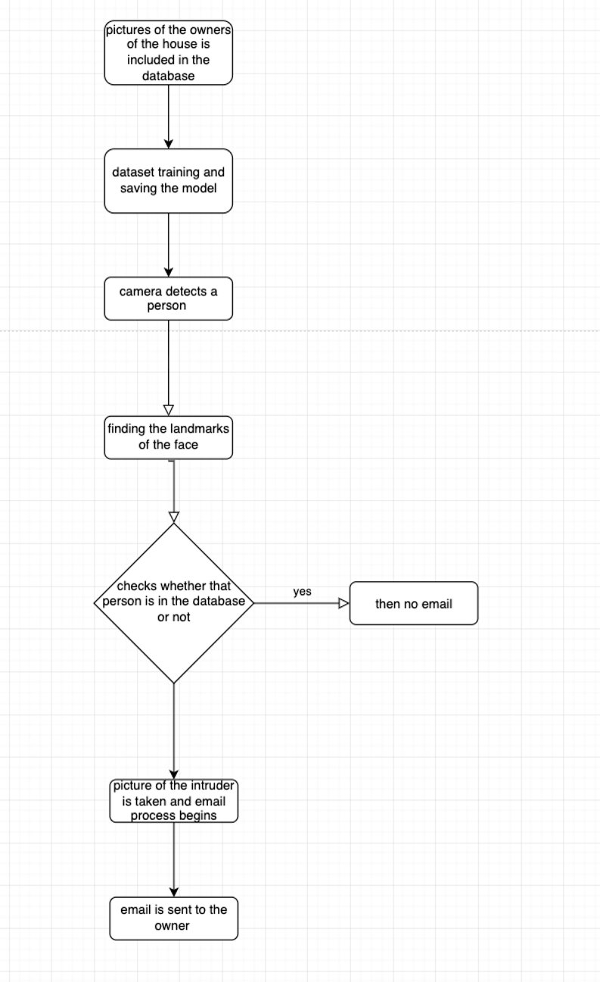

**5 Implementation of System**

This application/project identifies intruders in a specified camera view and sends an alert email to the admin/owner with sample intruder photographs.

We have used the face recognition python module for this.

It's a cutting-edge facial recognition module from dlib, with a deep learning backend.

The model detects intruders with an accuracy of 96 percent (approximately).

As this system will be implemented in some houses or offices and we don’t want it to detect the owners or known people as intruders we will trail it with the set of pictures of known people. So that it can remember them and don’t classify them as intruders.

Then we will start the system as whenever a person comes in front of the camera it will check the facial characteristics and will match it with the existing database and if it does not match then it will save the pictures in the specified location(intruder folder) and will also send it to the specified email address (given by the owner).

Step 1: Create a simplified version of the image by encoding it with the HOG technique.

Step 2: Locate the primary features of the face, such as the nose, mouth, and ears.

Step 3: Encoding Faces is the third step. Here, we use an OpenFace-developed pre-trained Convolution Neural Network.

Step 4: Decipher the encoding for the person's name.

Compare which person's measurements are the most similar to our face's measurements.

**6. Results and Discussion**

This is the mail that we got after our program took pictures of intruders and sent them to the specified mail id.

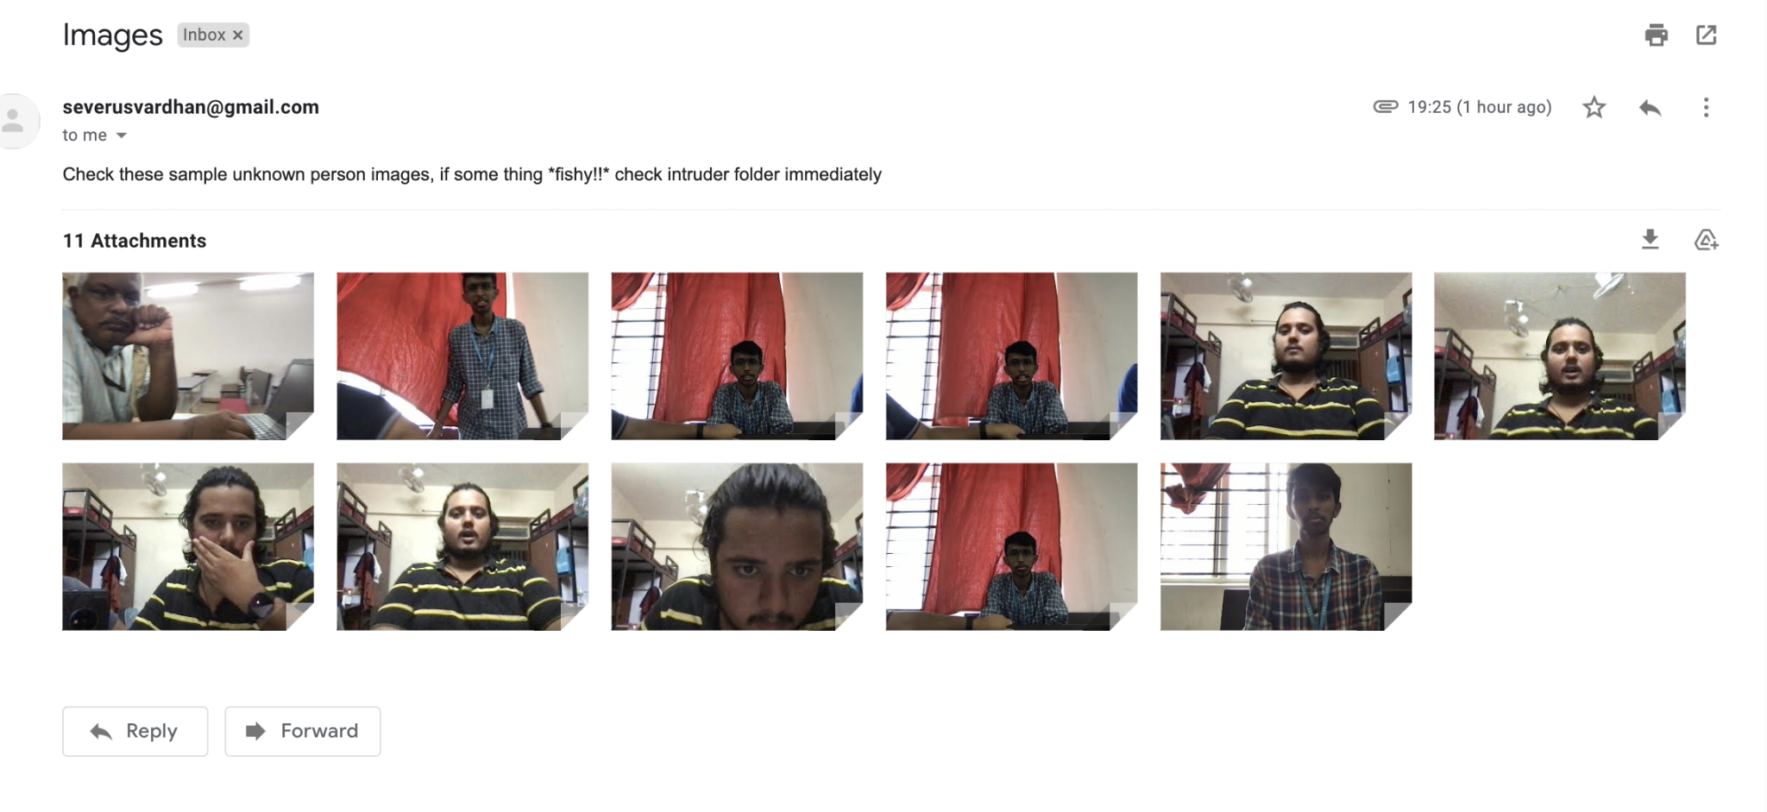

This is the picture of our intruder folder where our program saves the pictures of intruders.

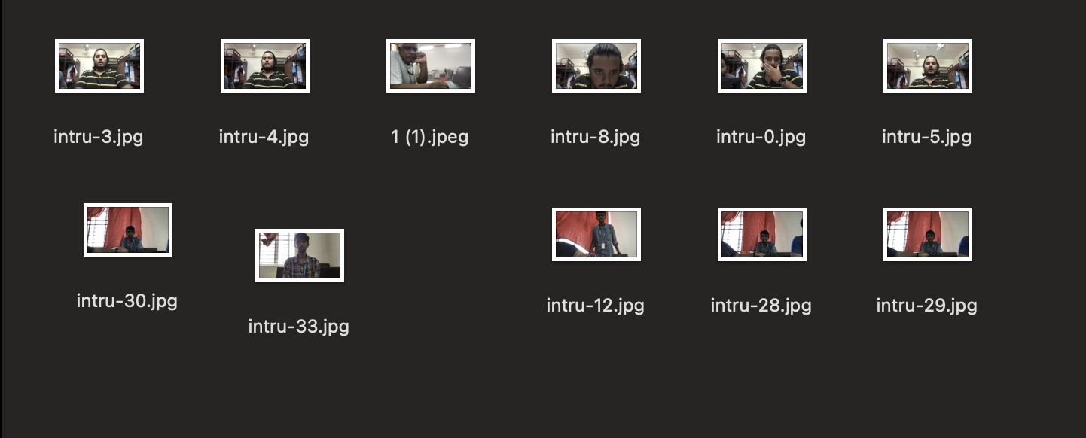

**7. Conclusion and Future Work**

We made an intruder detection and mailing system after going through a lot of existing solutions.

Some of the solutions are using radar systems for detection but radio waves are harmful and some are using any kind of motion detection which again is not very efficient.

We are using face recognition and other python modules which are very efficient and not at all harmful. They are very cheap to implement and work really well. It classifies a person as a known person or an intruder based on facial characteristics and if found as an intruder it not only saves its image in a local disk but also sends mail to the specified mail id by the owner immediately so that in case anything happens to the system afterward still it can be checked who was the intruder.

As part of future work, we plan to:

* add a user interface
* We will try to read other characteristics apart from the face
* and make it available 24/7 and throughout the year
* to enhance the security and privacy of user data (if provided)
* Embed it with security cameras and scale it.

**8**. **REFERENCES**

<https://ieeexplore.ieee.org/abstract/document/8035326>

<https://www.researchgate.net/profile/Nico-Surantha/publication/335915022_An_IoT_based_House_Intruder_Detection_and_Alert_System_using_Histogram_of_Oriented_Gradients/links/5dc25802299bf1a47b191372/An-IoT-based-House-Intruder-Detection-and-Alert-System-using-Histogram-of-Oriented-Gradients.pdf>

<https://ieeexplore.ieee.org/abstract/document/7916526>

<https://ieeexplore.ieee.org/abstract/document/8644109>

<https://www.researchgate.net/publication/316599266_INTRUSION_DETECTION_SYSTEM>

<https://www.ijedr.org/papers/IJEDR1702161.pdf>

<https://www.ijeat.org/wp-content/uploads/papers/v2i4/D1428042413.pdf>

<https://www.academia.edu/Documents/in/Intrusion_Detection_System>